Not So Different: Ability Employment Support Officer (Part-Time)

Ability Employment Support Officer (Part-Time – 3 days per week)
Not So Different is a social enterprise established in 2016 to promote equality and inclusion for neuro-diverse individuals and their families. We work to improve opportunities for neuro-diverse individuals through education and employment.
Not So Different Ability Programme has two aims:
- supporting neuro-diverse young people (15-29 years) without an intellectual disability and their families through education to employment whilst promoting equality and inclusion
- increasing capacity of families, educators, healthcare professionals, service providers and employers through neuro-diversity awareness training and supporting neuro-diverse individuals to employment
Ability Employment Support Officer is responsible for working with young people aged 15-29 years with a diagnosis of autism spectrum disorder to transition from education to employment. The Ability Employment Support Officer works with education providers and employers to create transition pathways designed specifically for people with ASD. The Ability Employment Support Officer reports Ability Programme Manager under the governance of the Board and in compliance with Ability Programme Requirements. We are seeking an individual with considerable experience of working with young people specifically in the areas of neuro-diversity, social inclusion, employability and working with those most distanced from labour market and those from disadvantaged neighbourhoods. Excellent data management skills and experience is essential for this position.
The ideal candidate will have extensive experience of working with young people with ASD and their families in collaboration with their educators, healthcare professionals and service providers to support individuals through education to employment whilst promoting equality and inclusion. A level 7 qualification or relevant experience of data management, social inclusion, sociology, community development, philosophy or other related fields is essential. Department of Health Salary Scale applies. Full job description and application form attached.
To apply please submit cover letter and completed application form by email to deirdrelynch@notsodifferent.ie by the extended deadline of 5pm Thursday 9^{th.} January 2019.
Not So Different is an equal opportunity employer.
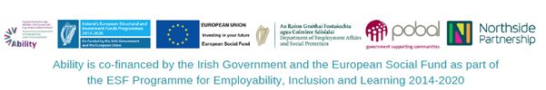

Region:
Dublin

